Usually, basic visuals are effective at communicating your message. But in some cases, you need another type of chart. The two resources below help you pick the right chart.  
﻿﻿  
﻿﻿

## **Chart Guide**

Choose and design the perfect chart, with the help of this Chart Guide.  
﻿﻿Created by Michiel Dullaert, founder of dePerfecteGrafiek.nl (Dutch for The Perfect Chart).  
﻿﻿  
﻿﻿You can download your own copy of the Chart Guide [here](http://chart.guide/poster).  
﻿﻿

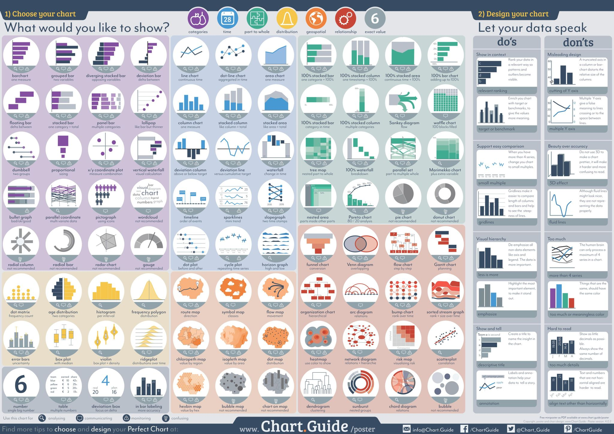

﻿﻿

## **Data Visualization catalogue**

## **﻿﻿**

## **﻿﻿**

**Here's another resource** [**to help you choose the right chart**](https://datavizcatalogue.com/).

You can search by function and choose the ideal visualization.

  
